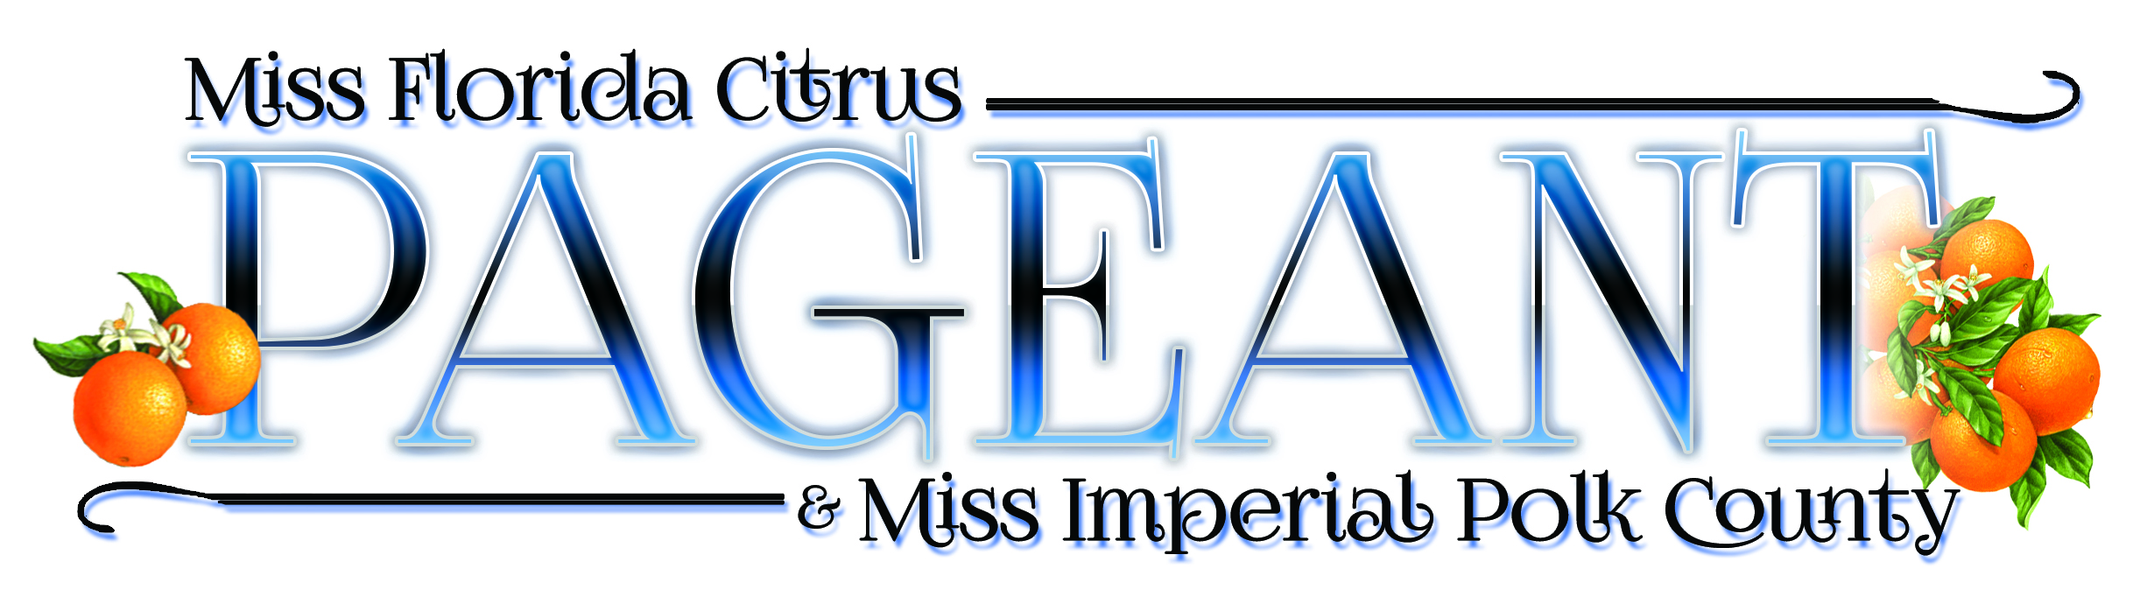


Miss Florida Citrus and Miss Imperial Polk County Crowned

Winter Haven, Fla. (March 22, 2016)—The Miss Florida Citrus/Miss Imperial Polk County Scholarship Pageant was held at Theatre Winter Haven in Winter Haven, Fla. on March 19, 2016, crowning Stephanie Capon, of Miami, as Miss Florida Citrus and Taylor Pohl, of Wauchula, as Miss Imperial Polk County. Hosted by Mary Katherine Fechtel, Miss Florida 2016, and David Lang, of Regalia Magnificent Apparel, the Miss America preliminary pageant contestants were judged on the following criteria: Interview/On Stage Question, Evening Wear, Talent, and Swimsuit, with over $3,000 in cash and prizes awarded to the top five finalists. Both titleholders will go on to compete in the Miss Florida Pageant, which takes place in Lakeland June 28—July 2, 2016, the winner of which will compete in the Miss America pageant.

Stephanie Capon is attending the University of Florida working on a Master of Science degree in Management and hopes to earn a J.D. in law. She was sponsored by Ben Hill Griffin, Inc. and is currently a White House Internship Program Intern for the Office of Public Engagement and Intergovernmental Affairs in Washington, D.C. A daughter of two Cuban immigrants, she is fluent in Spanish, is an inductee of the University of Florida Hall of Fame and a University Scholar, and would like to implement arts legislation in hospitals and public universities across Florida. Her platform is “A Healthy He(art)beat: Arts for Community Wellness,” and she would like to focus more attention on garnering greater support for the arts as a tool for community health and wellness. She will receive a $1,000 scholarship along with numerous other prizes and will represent the Florida citrus industry at various trade shows and events throughout the year.

Taylor Pohl is in graduate school at the University of Florida seeking a Master of Science degree in Animal Science, specializing in reproduction. Sponsored by RiverBrite Citrus, Inc., she is a Florida Medallion Scholar and the recipient of the Susan Brown Memorial, Farm Credit, James Wilmer Crews, III, Buford E. Long, and Masonic Scholarships, as well as a member of the Gator Collegiate Cattlewomen Club, Block and Bridle and a 2015 Livestock Judging Team Member at the University of Florida. Her platform is the “Importance of Agricultural Education” and she believes that reminding the public about the importance of agriculture will also help individuals recognize what our nation was founded upon. She will receive a $1,000 scholarship, along with other gifts, and will represent Polk County at various events throughout the year.

The Florida Citrus Queen Pageant began in 1924 and has been part of the Miss America Organization off and on throughout the years, with the name changing to Miss Florida Citrus in 1984. At one time, Miss Florida Citrus was a salaried employee of the Florida Department of Citrus, chosen over a three-day period of intense interviews, with the winner traveling throughout the world as the industry ambassador. However, the program was put on hiatus in 2004 due to budget constraints and fallout from the struggles the industry has faced with decline from disease. Last year marked the return of the Miss Florida Citrus program to help promote Florida’s citrus industry on a grass roots basis, made possible through a generous grant from the 1966 Florida Citrus Queen, LaVoyce Leggett Porter, and her husband Lanier Porter, along with numerous sponsors of the program.

For more information or to schedule an appearance, please visit the web site at www.missfloridacitrus.net or contact Executive Director, Brenda Eubanks Burnette at (561) 351-4314 or BBurne1003@aol.com.

Brenda Eubanks Burnette,
Executive Director
BBurne1003@aol.com
(561) 351-4314
2506 Gardens Parkway, Palm Beach Gardens, FL 33410

